**Analysis of CO2 emissions and non-fossil fuel energy technologies**

**Introduction**

In this report, I delve into the complex relationship between carbon dioxide (CO2) emissions, socioeconomic factors, and the evolving landscape of non-fossil fuel energy technologies.

By leveraging various datasets and statistical techniques, I aim to uncover insights that shed light on trends, correlations, and potential future trajectories.

1. **What is the biggest predictor of a large CO2 output per capita of a country?**

To understand the factors influencing CO2 output per capita, I analyzed data on annual CO2 emissions, GDP per capita, and energy usage, particularly focusing on fossil fuel consumption and motor vehicle ownership per 1000 people. I found strong positive correlations between CO2 emissions per capita and both GDP per capita (0.745) and fossil fuel usage per capita (0.913).

Interestingly, the correlation between CO2 emissions and nuclear energy usage is negligible, indicating that nuclear power may not significantly contribute to carbon emissions.

I also found a moderate positive correlation between CO2 emissions and motor vehicle ownership per capita, highlighting the impact of transportation on carbon output.

This suggests that economic prosperity and reliance on fossil fuels are significant predictors of high CO2 emissions per capita.

**2. Which countries are making the biggest strides in decreasing CO2 output?**

To identify countries with significant reductions in CO2 output, I examined changes in CO2 emissions and CO2 emissions per capita between 1991 and 2021.

Bar charts were created to visualize the top 10 countries with the biggest negative overall change and negative change per capita in CO2 emissions.

The analysis revealed that Kuwait, Moldova, and French Guiana are among the top countries with the most substantial percentage reductions in CO2 emissions over this period. This indicates that these countries have implemented effective measures to curb their carbon emissions.

1. **Which non-fossil fuel energy technology will have the best price in the future?**

Turning my attention to renewable energy, I explored the cost dynamics of non-fossil fuel technologies over time. Leveraging data on the levelized cost of energy for various renewable sources, I employ linear regression modelling to forecast future trends in energy costs.

My analysis indicates that the cost of solar photovoltaic technology is experiencing the most significant decline over time, with costs decreasing at a rate of approximately $0.029 per kilowatt-hour (KWh) annually.

Conversely, other renewable sources such as geothermal, concentrated solar power, and onshore wind exhibit slower rates of cost reduction.

This table displays the approximate average cost per energy unit produced. It is denominated in US dollars:

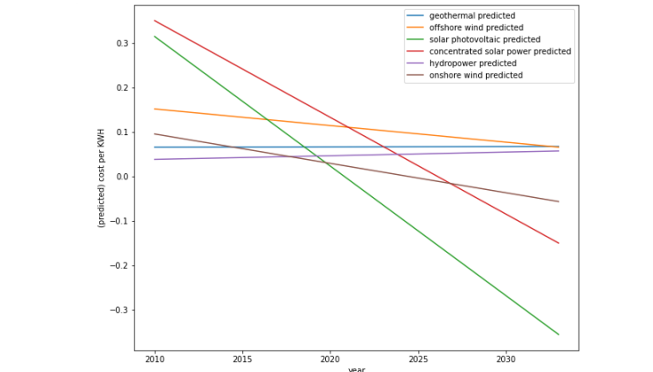

*Figure1: Linear regression lines of the different non-fossil energy sources*

**Conclusion**

My analysis highlights the intricate interplay between CO2 emissions, socioeconomic factors, and renewable energy technologies. While countries continue to grapple with the challenge of reducing carbon output, advancements in non-fossil fuel technologies offer promising avenues for mitigating climate change. By leveraging data-driven insights, policymakers and stakeholders can make informed decisions to accelerate the transition towards a sustainable energy future.

**Summary of what the code does and doesn't do, along with explanations for each question:**

**1. What is the biggest predictor of a large CO2 output per capita of a country?**

**What the code does:** The code merges several datasets on CO2 emissions, GDP per capita, energy usage, and motor vehicle ownership per capita. It then plots the correlation between CO2 emissions per capita and various factors like fossil fuel usage per capita, GDP per capita, and motor vehicle ownership per capita. Finally, it calculates the Pearson correlation coefficients between CO2 emissions per capita and these factors.

**What the code doesn't do:** It doesn't provide a definitive answer to the question but rather analyzes correlations between CO2 emissions per capita and different factors. While it shows correlations, it doesn't establish causation.

**2. Which countries are making the biggest strides in decreasing CO2 output?**

**What the code does:** The code pivots the emissions data to compare emissions between 1991 and 2021, calculates the relative change in emissions for each country, and sorts them to find the countries with the biggest negative changes. It then visualizes the top 10 countries with the biggest negative changes in CO2 emissions between 1991 and 2021.

**What the code doesn't do:** It doesn't delve into the reasons behind the changes in emissions for each country or provide a comprehensive analysis of the strategies employed by these countries to reduce emissions.

**3. Which non-fossil fuel energy technology will have the best price in the future?**

**What the code does:** The code retrieves data on the levelized cost of energy for various non-fossil fuel energy sources from GitHub. It selects data for the world, performs linear regression for each energy source to predict future costs, and plots the predicted cost per kilowatt-hour (KWH) from 2010 to 2034. It also calculates and displays the slopes of the regression lines, indicating the rate of change in costs over time for each energy source.

**What the code doesn't do:** It doesn't provide insights into the underlying factors driving the predicted cost trends for each energy source or consider other factors that could influence future energy prices, such as technological advancements, policy changes, or market dynamics.